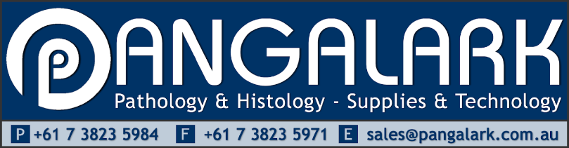

Anti-Slavery Policy Statement

This policy reflects Pangalark Laboratory Technology’s commitment to ensure to the best of our ability that there is no modern slavery in any part of our business operations. We are committed to acting ethically and with integrity in all business dealings and relationships, and where possible, to ensure modern slavery is not taking place in our
own business or supply chain.

Definitions
The term ‘modern slavery’ describes situations where coercion, threats or deception are used to exploit victims
and undermine their freedom. Coercion, threats and deception can be explicit or implicit.
The Modern Slavery Act 2018 (Cth) ‘Act’ defines modern slavery as including eight types of serious exploitation;
trafficking in persons, slavery, servitude, forced labour, forced marriage, debt bondage, the worst forms of child
labour and deceptive recruiting for labour or services.
The worst forms of child labour mean extreme forms of child labour that involve the serious exploitation of
children, including through enslavement or exposure to dangerous work. The worst forms of child labour does
not mean all child work.
Under Australian law, modern slavery is defined in the Act. In the event of any inconsistency, the definitions in
the Act take precedence over this policy.

